CAC Blog 5

Well here we are at this bizarre and very challenging time in our world history, BUT I have good news for you about our little world.
Following our successful camp 4 during the Covid emergency, we were cautious about starting anything new in spite of having lots of bits of funding arriving. THANK YOU those of you who bought a Christmas card “The Gift of an Eye” for someone who has everything and those of you who donate regularly.
So: Early December, we were contacted by Alansana Touray who works as a surgeon at the main eye centre in Knifing. He told us about his village which is called Sambang, it is nearly 200 miles from the conurbations where tourists may be found. He said that there were about 36 villages local to Sambang who could take part. He wrote that every time he went home to visit his village “many people come to me with eye complaints, unfortunately I cannot help them….”
He suggested that Cataracts are curable might be interested in carrying out a Community Screening of eyes in this area. He said he would work over his weekend unpaid, but we would need to pay for transport for him and his colleague from the Bansang Hospital (50 kilometres away). Also for certain items and materials to conduct the survey and provide basic eye care when required. These included

Eye ointment, two different kinds of eye drops, sanitizer, tissues, facemasks and fuel. AND GLASSES

This interested us. The cost benefit was obvious. Our ethos has always been to do the greatest good we can do for the greatest many, -given the means we have at our disposal.

Curing cataracts benefits the individual AND those around them. Sight is fundamental to so many aspects of life, particularly in a third world country. Mobility, independence, self-reliance, productivity and physical and mental wellbeing all come to mind.

The Eye screening would mean that if we carried out our next camp there then the patients could be easily assembled. It meant that Alasana who we consider to be a friend, would be able to support his community in a very meaningful way AND some of the eye problems that are common in such communities may easily be fixed. The last time Jim and I visited The Gambia last year, there was a significant problem with conjunctivitis. We saw many people really suffering. Poverty, dusty conditions and lack of knowledge of basic hygiene exacerbated the problem. This underlined for us what a cost effective strategy this was. ALL of the people screened would have an experience of receiving professional medical help, many could be treated simply. A real positive.

He promised us a full report of his findings, which he did. They identified over 70 cases of mature cataracts. Various people were referred to SZRECC the main hospital because he believed they had Glaucoma.

Over 40 of those seen were given medication and advice on the spot, a few were issued with glasses (I am not sure where these came from). A very positive and pleasing result.

The screening took place in December in period 18th to 20th December. The surgeon collecting screening information, you will see he has medication ready and a selection of used glasses.

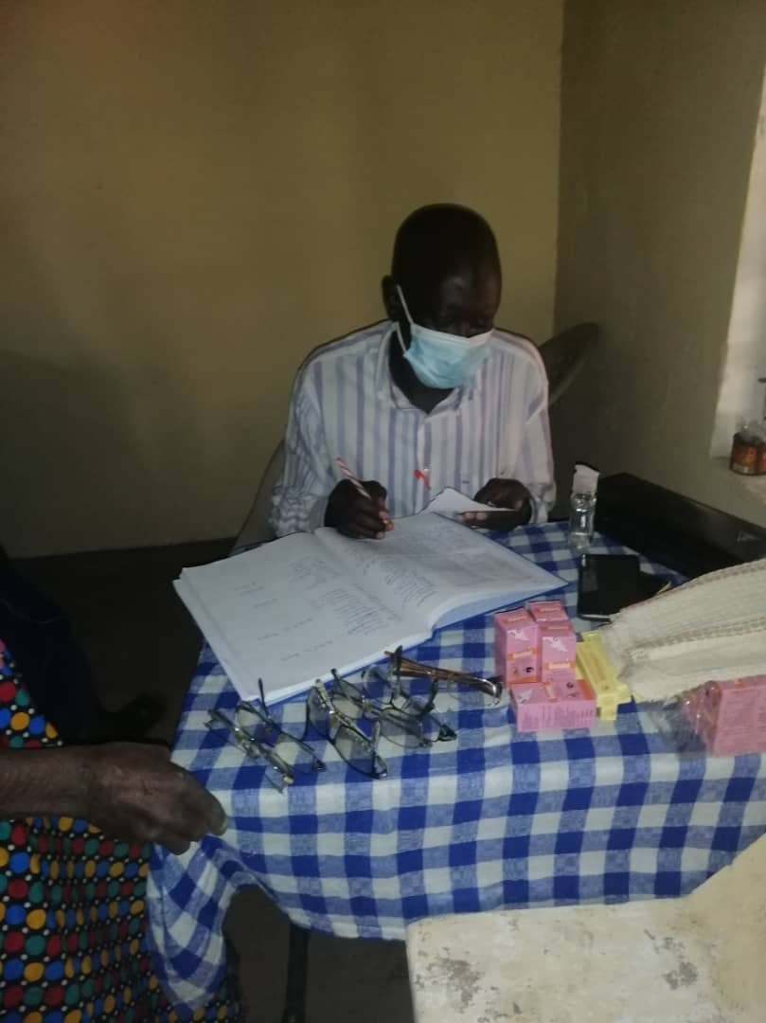
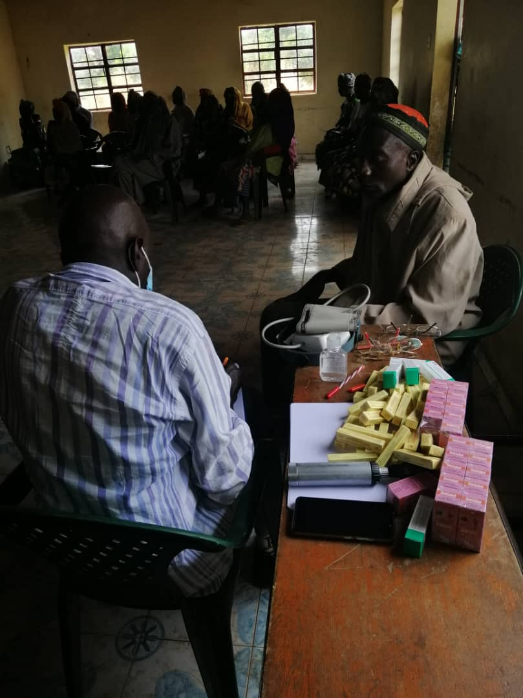

The acuity test and villagers awaiting their screening. Note their beautiful clothing a signal of their
respect to the nursing and other medical staff. This event is ‘an outing’ - rare in their villages.

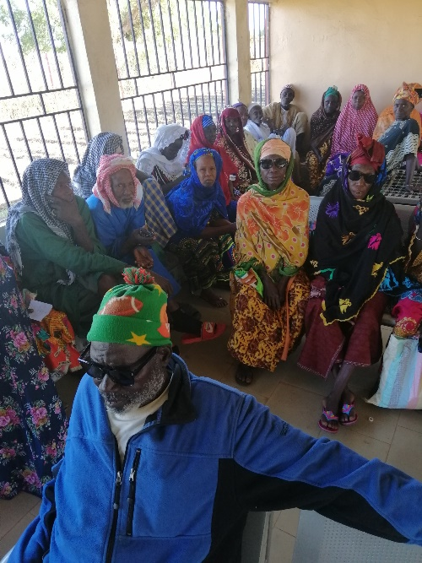
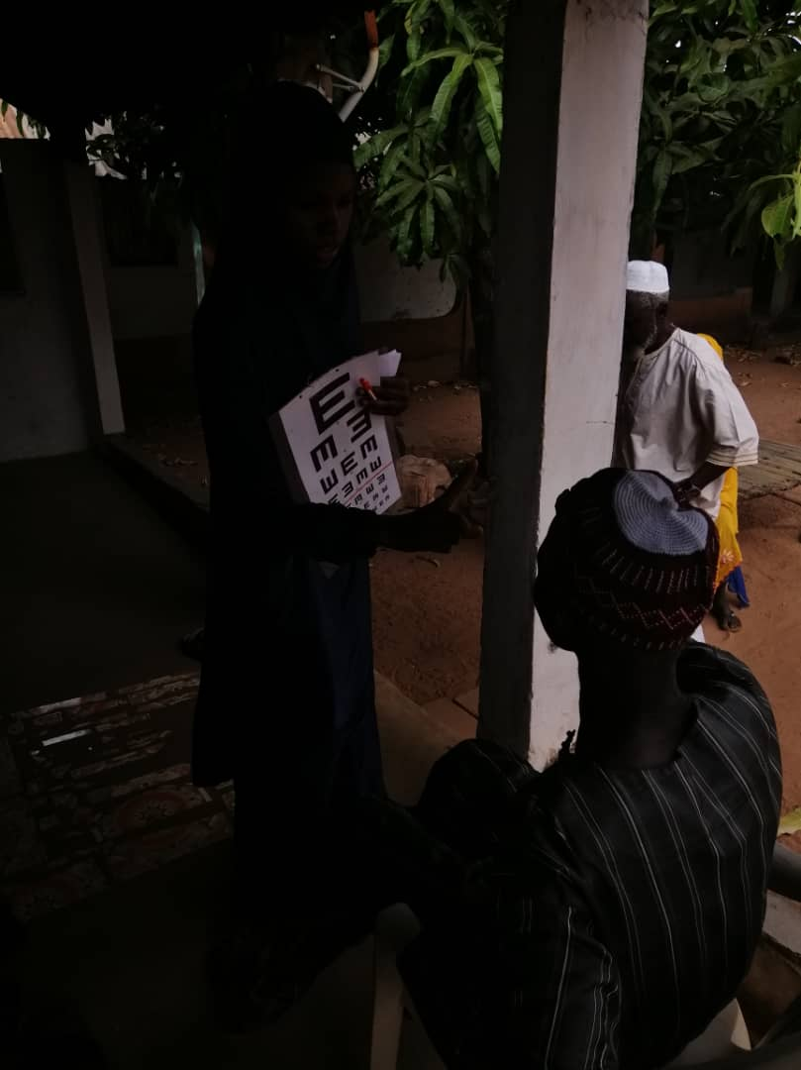

The cataract camp took place 12th 14th January 2021. 52 cataracts were done.
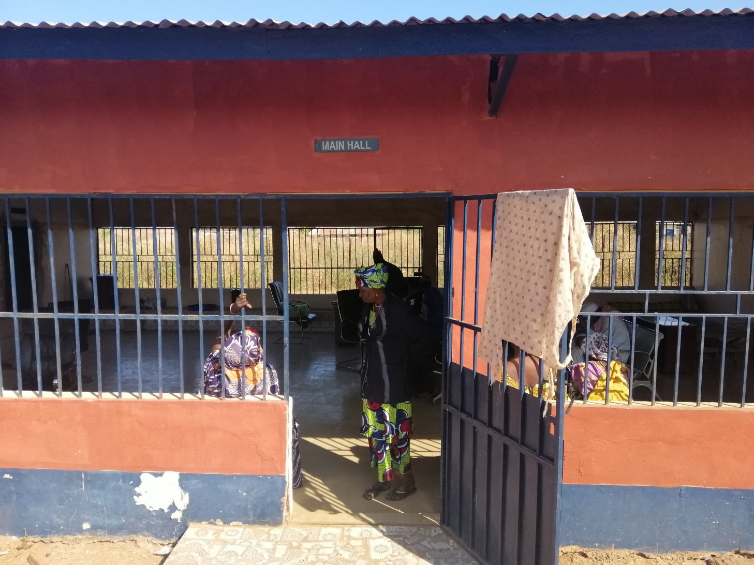
This is the hall in Katamina used by the team

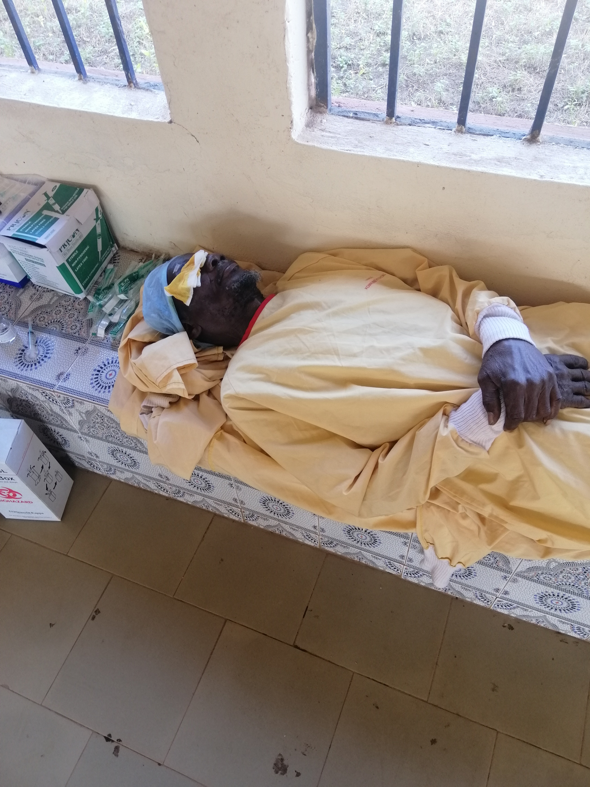
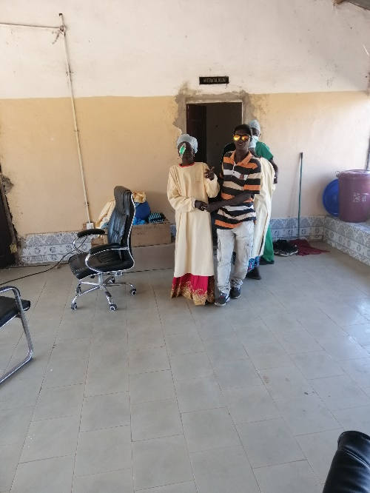

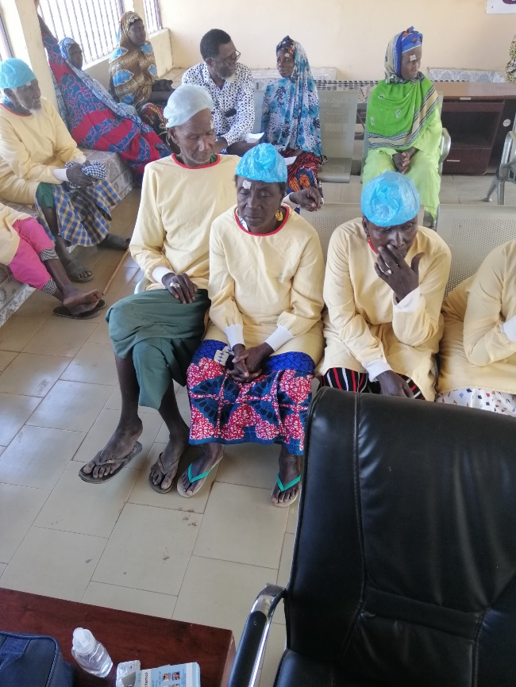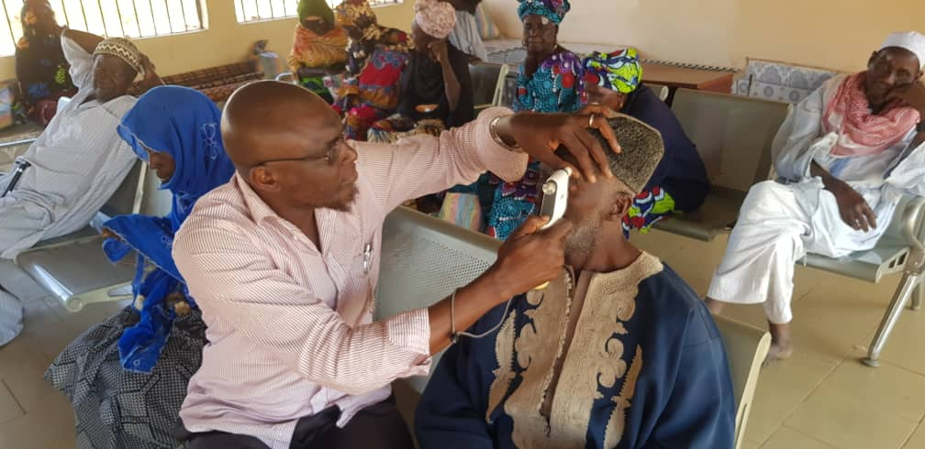
Patients waiting patiently to have their dressings removed. Alasana, who is pictured below, said “Their eye pads were removed, eyes cleaned and smiling started on faces as a new world is seen, all of them had a very good outcome”.
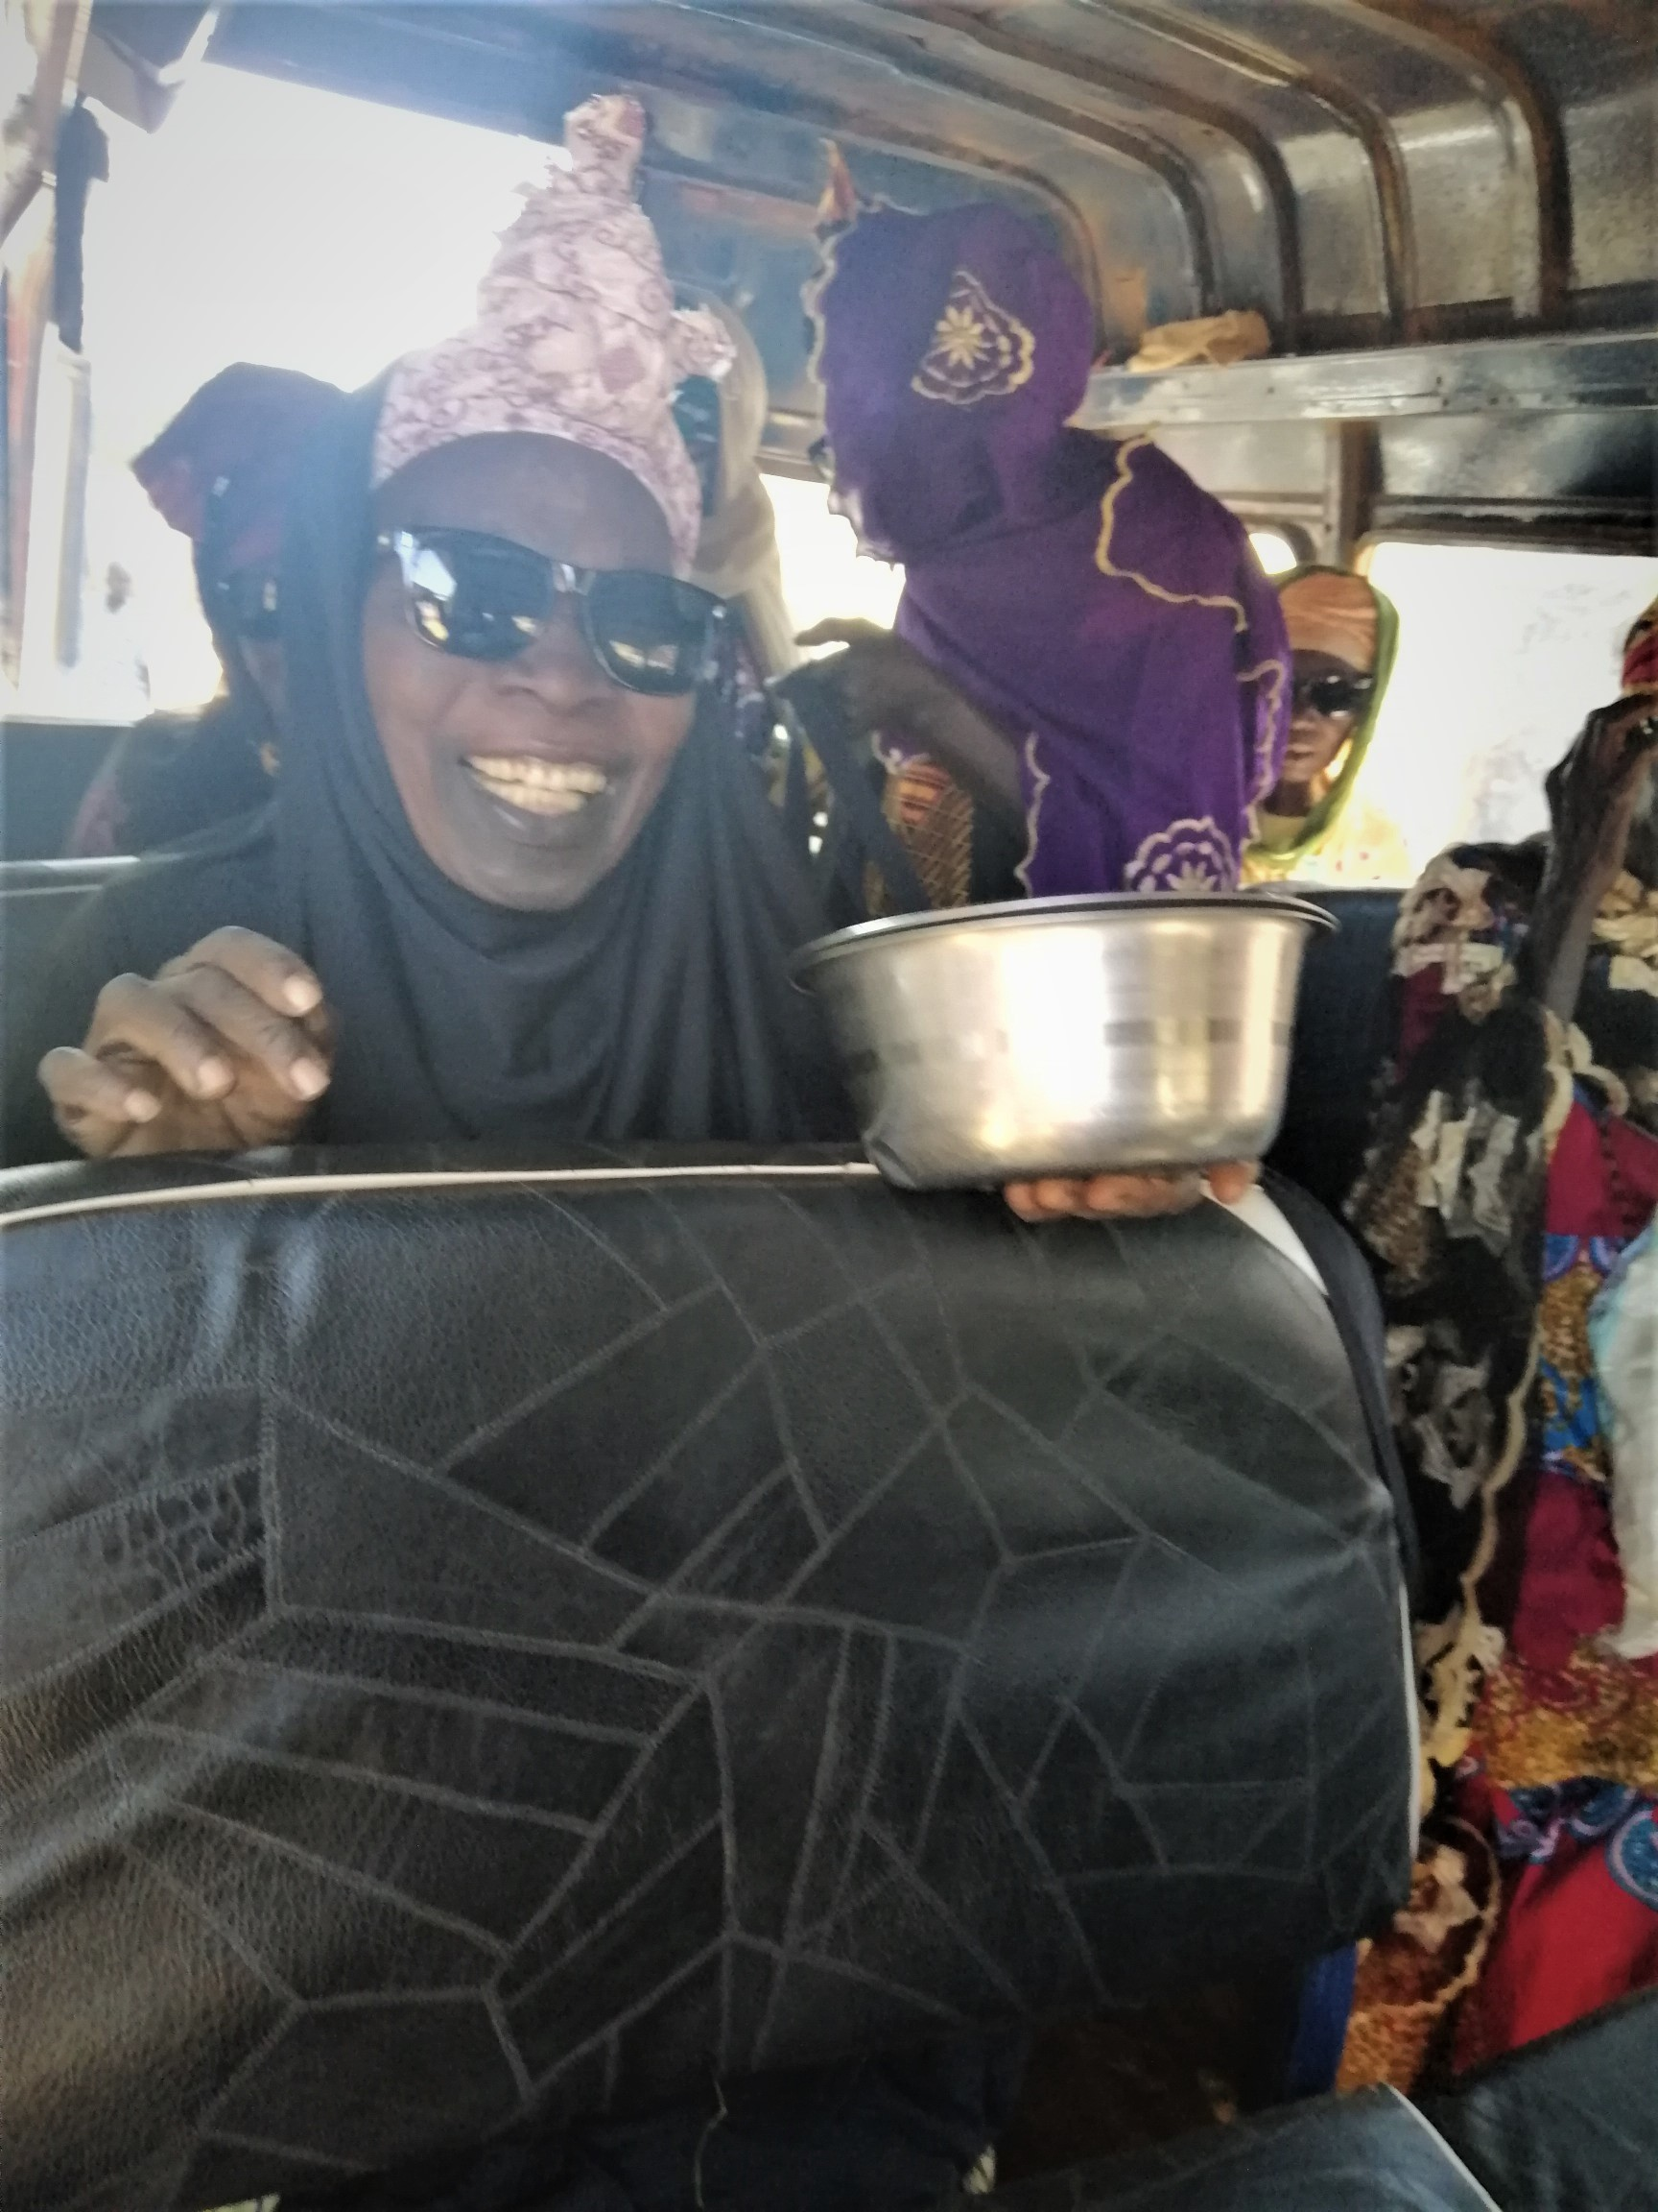
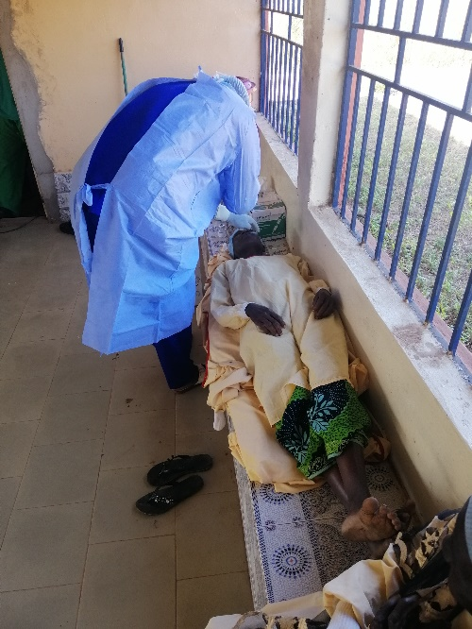
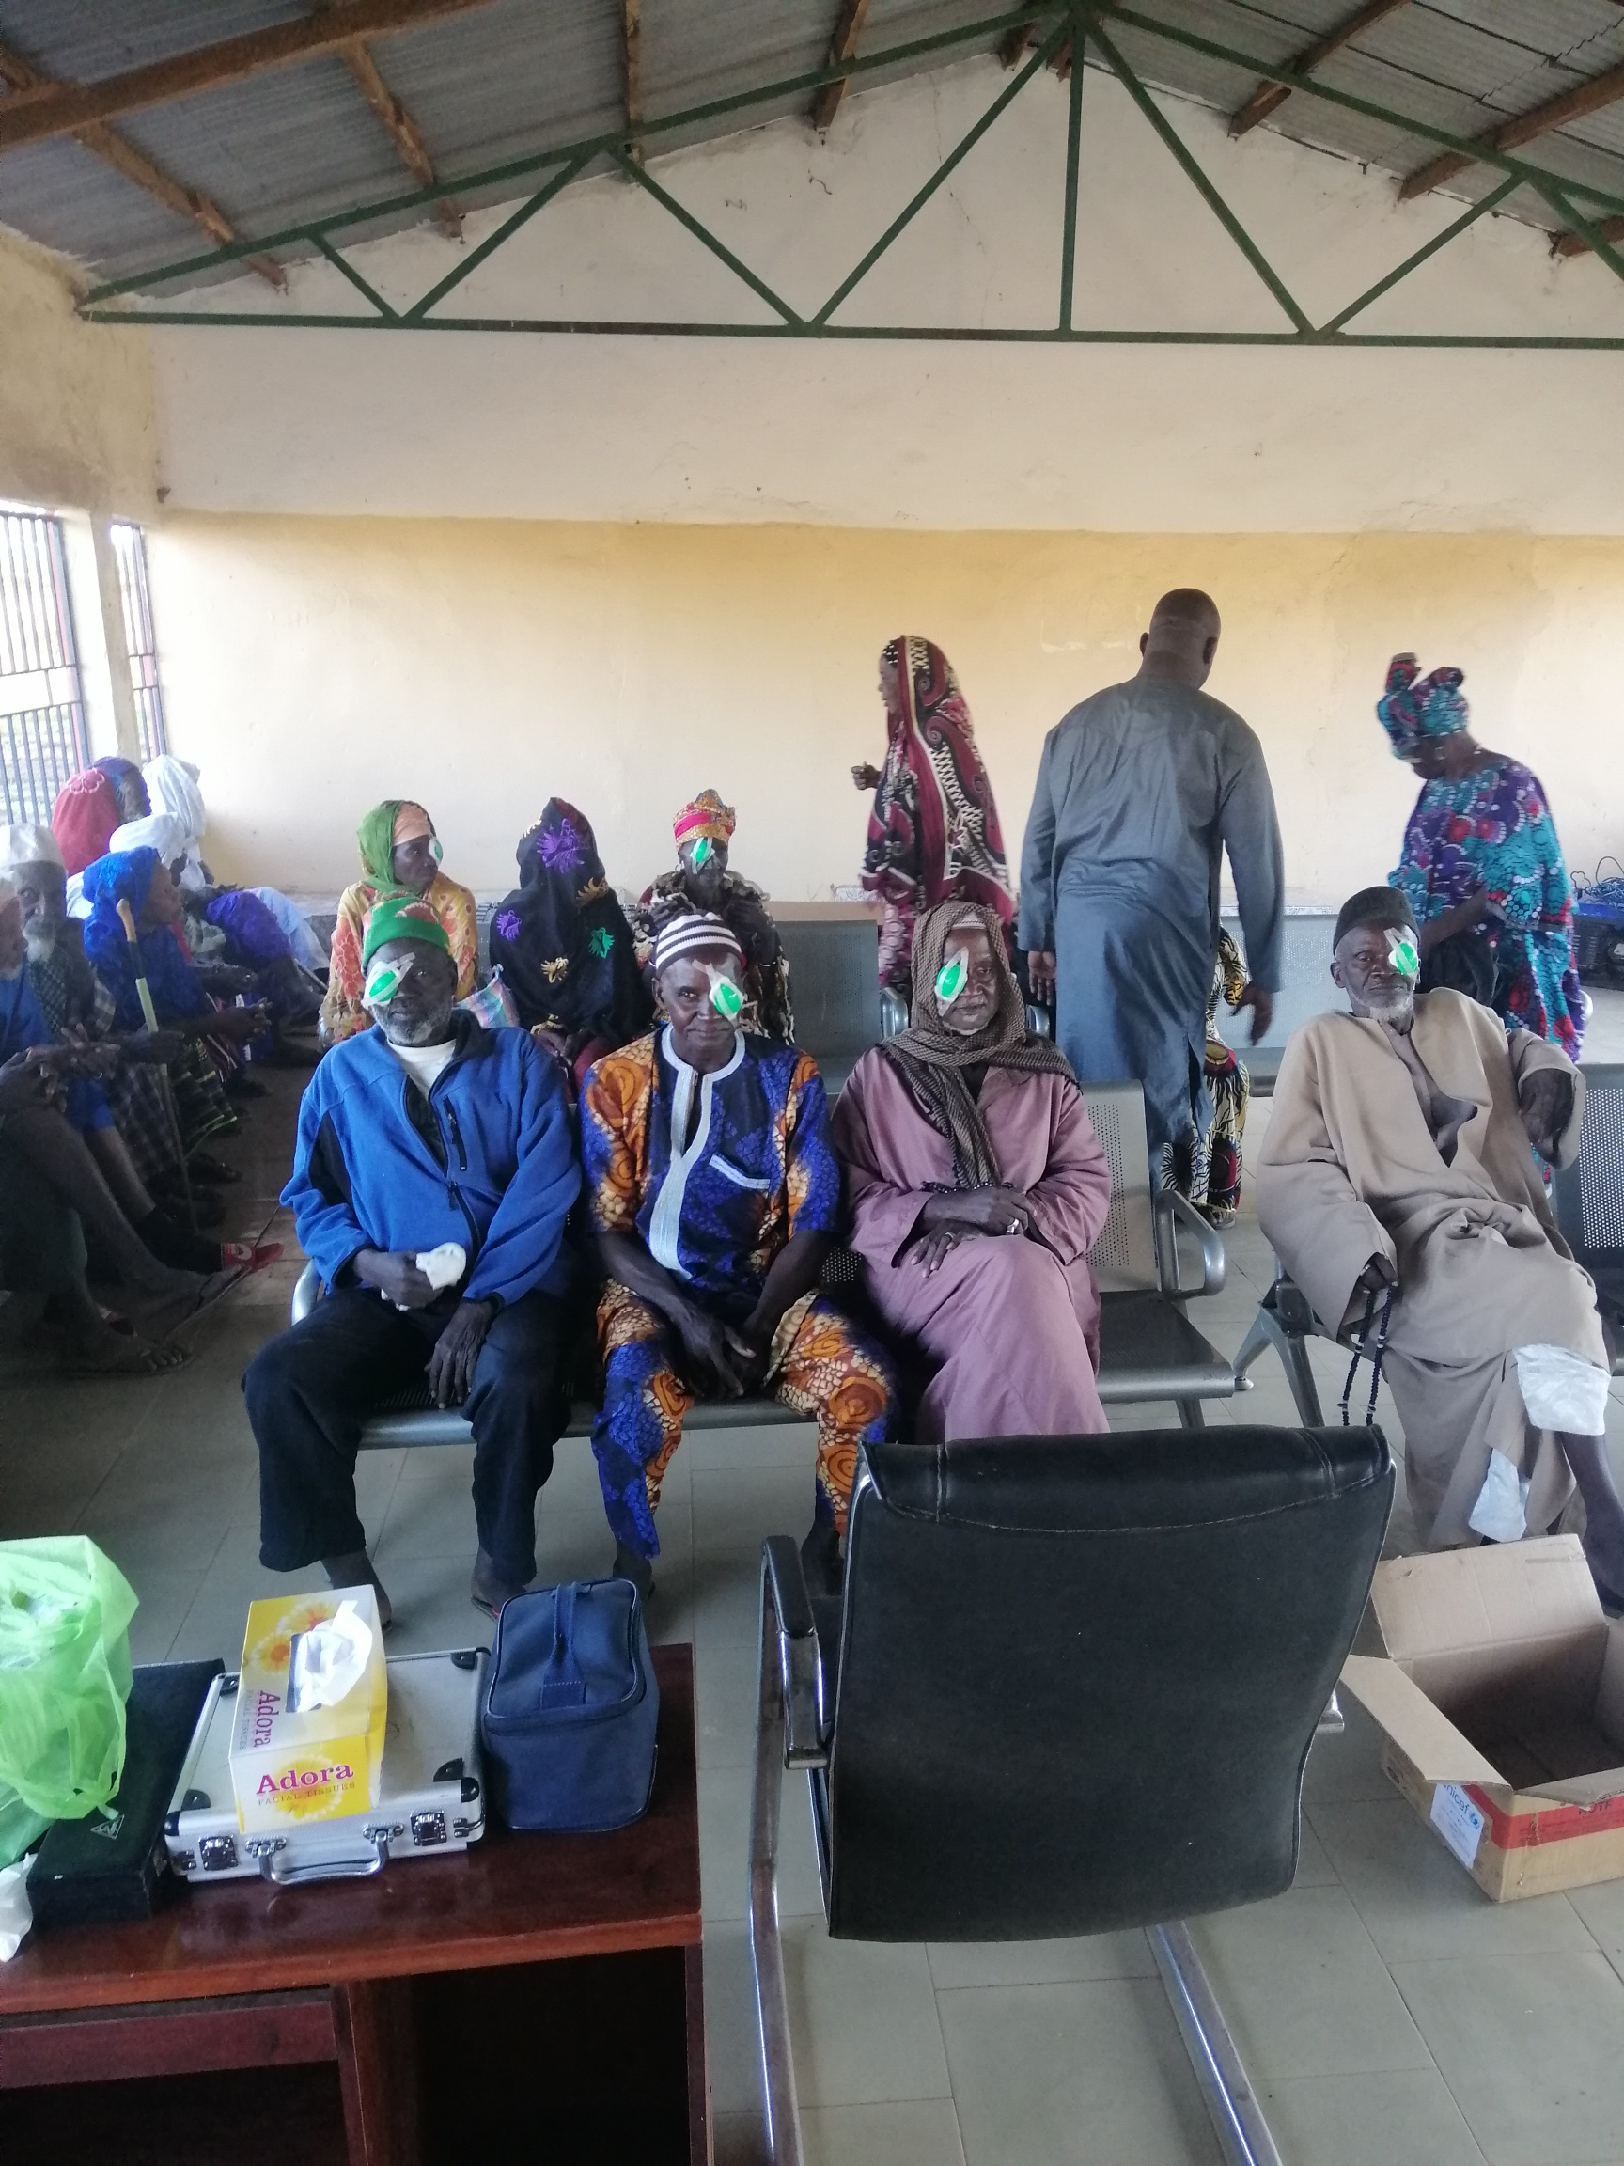

The surgery began around 8.30 am on Friday. The team operated on 13 patients before they had lunch and Juma which is Friday prayer. The session resumed at 3.30 8 more operations were done.

These patients were put up in rooms one for the men and one for the women overnight. They were checked the next morning. They were then sent home in a Gele Gele to avoid the tiring walk home.

You can see the smiling woman in the back of the Gele Gele on her way to “see” her waiting family.

The rest of Saturday was spent operating on the 31 remaining patients who were allowed to spend the night in their own homes but had to return the next morning to have their dressings removed and learn how to administer their all important eye drops.

This is the Gele Gele taking people, and their bedding back to their villages.

